LOGLINE
‘Altered Minds’ is a psychological thriller about a tormented son who makes a desperate bid to save his sanity by unearthing family secrets before his father dies.
SHORT SYNOPSIS
Plagued by terrifying visions, Tommy Shellner, a writer on the brink of insanity, hijacks a family celebration in a desperate attempt to force a confession from his once CIA psychiatrist father. The warm reunion in their family home turns icy and spirals out of control when Tommy alleges his father adopted three children for the purposes of psychological experimentation. www.Altered-Minds.com (Formerly titled The Red Robin)
ADVANCE CRITICAL PRAISE
“Superb ensemble performances makes ‘Altered Minds’ corrosively honest and engrossing as its mystery slowly unravels.”
-Rob Goald, Senior Editor, Film Festival Today

“An earnest psychological drama, beautifully shot, that’s at times as chilling – and sad – as Ang Lee’s ‘The Ice Storm’.”
-James Ulmer, International editor, Cinema Without Borders

“Enthralling psychological thriller with a strong point of view by writer/director Michael Wechsler exploring a sensational subject – mind control.”
-Alexander, Rotten Tomatoes Critic, FilmsinReview.com

“‘Altered Minds’ is an engrossing psychological thriller that doesn’t rely on special effects or other tricks to pull you in. Top rate acting and a taut script keep you guessing! Hirsch at his best since Ordinary People.”
-Adam Schartoff, Founder, Film Wax

“Michael Z. Wechsler’s ‘Altered Minds’ is a chilling, edge of your seat psychological thriller, the plot of which simultaneously exhumes the darkest secrets of both a family… and a nation. Judd Hirsch gives a career-redefining performance which revisits his beloved on-screen persona, then injects it with the most sinister of undertones. While harkening back to the darkest moments of Cold War America, ‘Altered Minds’ is also about who we are now, as seen through the eyes of a family you’ll be very glad isn’t yours.”
-Alex Simon, The Huffington Post

“Wechsler smoothly combines elements to create a family drama about secrets and lies in the shape of an effectively creepy thriller.”
-Caryn James, Film Critic, Indiewire

“A dark and moody psychological thriller, there is a chilly and desolate tension to ‘Altered Minds’, a film driven by a jagged sense of atmosphere and a series of grim but impressive central performances”
-Mark Adams, Chief Film Critic, Screen International

“‘Altered Minds’ delivers a quality mystery; a psychological thriller hidden within the trappings of a familial drama. It’s a walk down a long closet full of unexpected skeletons. This is a solid psychological thriller that keeps you guessing, with more than a few tricks up its sleeves to make for some arresting emotional and physical responses. While the film eventually explains itself beyond most ambiguities, the resolutions offered up don’t disappoint.”
-Mark Bell, Film Threat

“‘Altered Minds’ is a deliciously dark tale that uses its wintry setting to chilling effect. For a film that uses MKULTRA as a plot device, it’s fitting that Weshsler manages to continually manipulate the viewers’ expectations, right up until the final reel.”
-Hamish Hutchinson, Alloa Advertiser, Glasgow

“A near flawless script full of love, passion and the dark side of family life, director Michael Wechsler delivers his vision with a simple slap in the face. Wonderful actors and brilliant editing carry the audience down the path of demons we all have, or know someone who does. One can only hope this brings Judd Hirsch into the cinema world.”
-Paul Booth, Influx Magazine

KEY WORDS
psych, psychology, psychological, thriller, mystery, conspiracy, suspense, chilling, family, drama, psychodrama, trauma, post-traumatic, stress, PTSD, MK-Ultra, mind control, programming, programmed, feature, film, independent, crowdfunding

DIRECTOR’S NOTE:
I fell in love with cinema when I was eight and old enough to learn how to use Bell & Howell 8mm projector. I watched hundreds of hours of our family’s home movies. Viewing our clan’s unique on-camera antics was fascinating, but it was more than the clickety-clack of the projector and the magic of colors spilling across the screen that arrested my imagination. It was equating movies and storytelling with family. Film was a medium to capture the distinct rhythms and qualities of our flesh and blood, and birthed my desire to tell stories around the familial unit.
Before my first child was born, I struggled to find my creative muse. I came across an uncredited quote that seemed so obvious.
“Write about your obsessions. Those things you can’t stop thinking about.”
My top 3 obsessions came to mind. First, the family dynamics that led me to the film came clear, and second, my life-long fascination with trauma and the resulting Post Traumatic Stress Disorder (PTSD) condition. As survivors attest, trauma isn’t something you erase or cure. It’s a wild animal you learn to live with and tame on your own terms, and it was the subject of almost every screenplay I’d ever written. The third obsession was our long deceased family dog whose ashes I wanted to exhume from our former home years after I found out my folks buried his urn in the backyard. I was deeply conflicted about leaving my best friend from childhood behind and plotted my return to dig up his remains. Instead of picking up a shovel, I channeled those passions into a new screenplay, ‘Altered Minds’.
At first, there were only the images of my protagonist searching the neighborhood for his dog’s remains while his father celebrated his final birthday with the family. PTSD fused itself against that backdrop and gave bones on which to flesh out narrative and ultimately, a title.
“If you don’t give him a name, he will turn all the children into icicles.”
—Excerpt from Tommy Shellner’s book Altered Minds

CAST OF ALTERED MINDS
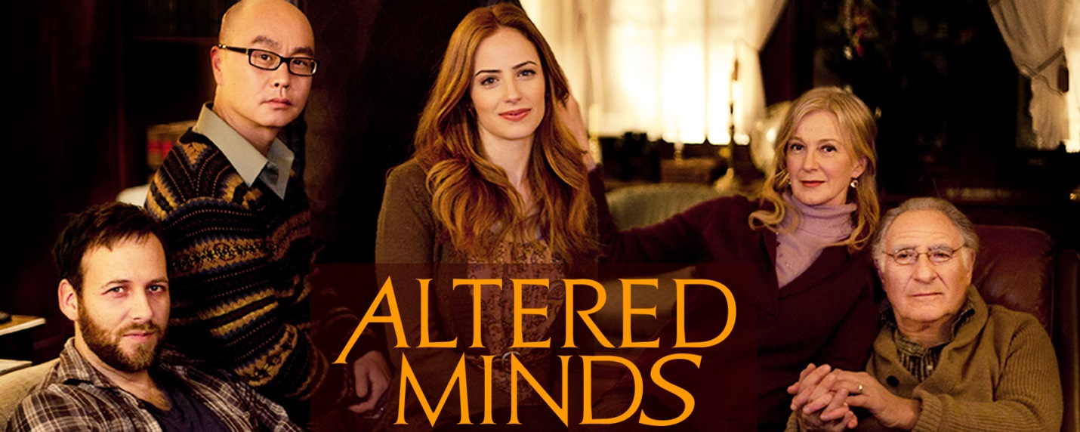

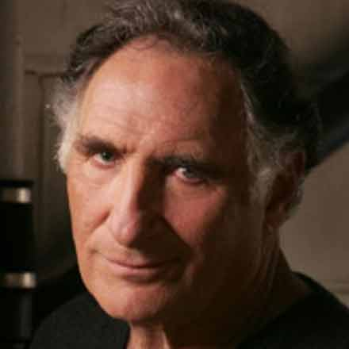 Judd Hirsch as Dr. Nathaniel Shellner — In film, Judd Hirsch received a nomination for the Academy Awards for Best Supporting Actor for his role in the drama ‘Ordinary People’, and also appeared in the acclaimed ‘A Beautiful Mind’. He portrayed the father of Jeff Goldblum’s character in ‘Independence Day’ and will reprise his role in ‘Independence Day: Resurgence’ slated for 2016 release. Judd has starred in numerous dramatic and comedic television series, winning Emmy Awards for Lead Actor in a Comedy Series for his role in ‘Taxi’ 1981 and 1983. He’s played many beloved characters appearing in ‘Dear John’, ‘Numbers’, and ‘Forever.’

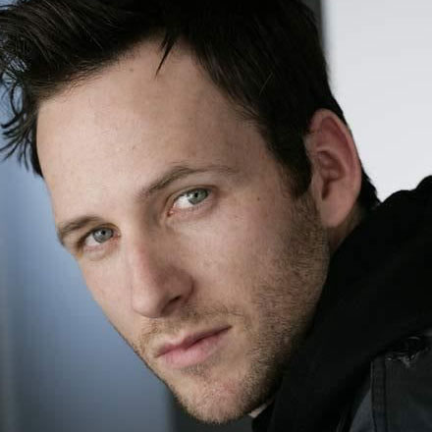 Ryan O’Nan as Tommy Shellner — Ryan O’Nan, who wrote and directed the Toronto Film Festival hit, ‘Brooklyn Brothers Beat The Best’, also starred in the Sundance Film Festival Favorite, ‘The Dry Land’. Most recently, he wrote, starred and produced the fantasy film ‘Albion: Rise of the Danann’ costarring John Cleese and Debra Messing. Ryan also has recurring roles in the hit shows ‘Ray Donovan’ (Showtime) and FX’S ‘Fargo.’

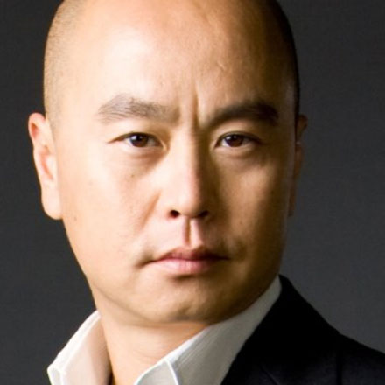 C.S. Lee as Harry Shellner — C.S. Lee starred as Vince Masuka on the hit Showtime series ‘Dexter’ starring Michael C. Hall and the comedic first season of ‘Chuck’. He is currently starring in HBO’S acclaimed series, ‘True Detective’ (Season 2).

 Jamie Ray Newman as Julie Shellner — Newman is best known for starring as Kristina Cassadine in soap opera General hospital, as Kat Gardener in ABC’s ‘Eastwick’, and as Dr. Tess Fontana in Syfy’s ‘Eureka.’ Most recently starred in the ABC series, ‘Red Widow’ and is a series regular on the NBC hit show ‘Grimm’.

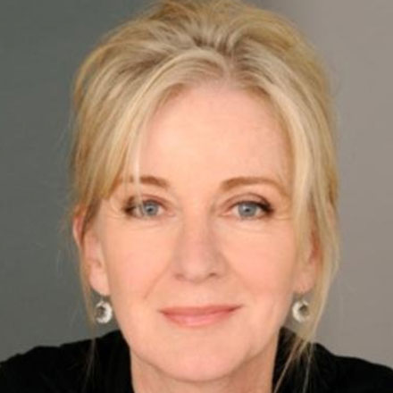 Caroline Lagerfelt as Lillian Shellner — Known to millions as Celia ‘CeCe’ Rhodes on ‘Gossip Girl’ and for her extensive film and TV credits, Caroline Lagerfelt has distinguished her career in international theatre and on Broadway. The recipient of Outer Critics Circle and Obie Awards, as well as a Drama Desk nomination, her career began under the auspices of theatrical legends Eva Le Galienne and Sir Ralph Richardson.

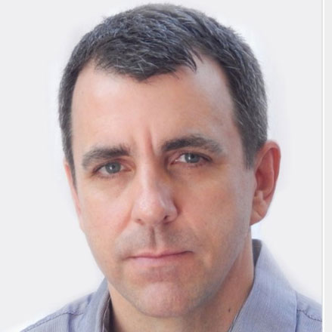 Joseph Lyle Taylor as Leonard Shellner — Joseph Lyle Taylor is known to fans of the F/X drama ‘Justified’ as small town bad guy Doyle Bennett. He has also shown quite a different set of capabilities in ‘Seven Days in Utopia’ with Robert Duvall, Lucas Black, and Melissa Leo. He also starred in Martin Mcdonagh’s ‘Seven Psychopaths’. Up next, he will be starring in Woody Allen’s latest feature.

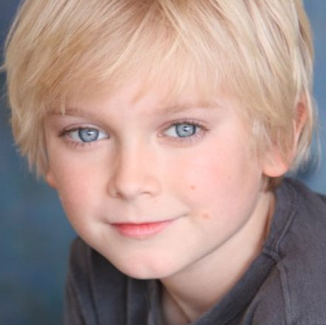 Hayden Signoretti as Young Tommy — Hayden started acting following in the footsteps of his sister Indigo, at ‘The Rockaway Theatre Company‘. He has been fortunate enough to appear in film, television and commercials. Hayden was given the lifetime opportunity to appear on Broadway in Disney’s Mary Poppins as Michael Banks and immediately followed that up as The Young Duke of York in Richard III. This year, he starred alongside Kelsey Grammar in the hit musical, Finding Neverland.

ABOUT ROWISH PRODUCTIONS

Rowish Productions, established by Michael Z. Wechsler and Shawn Singh, produces and distributes rich, transmedia entertainment content focused on cathartic stories of ordinary people transcending extraordinary circumstance. Rowish Productions is slated to follow up ‘Altered Minds’ with an original feature film ‘Modern Primatives’, a quirky love story based in mythology and mental illness, written and to be directed by Wechsler. Beyond that, are plans to produce a subversive Kafkaesque sci-fi caper ‘Caffeine’ and romantic comedy ‘Chemistry’, both co-written by Wechsler and Terry Keefe.
Rowish Productions takes its name from a combination of M. Wechsler and S.R. Singh’ son’s names. The rambunctious, precocious and energy filled sons became fast friends and insisted their fathers meet to ensure ongoing playdates, and the rest is history. It seemed fitting to credit the boys for the partnership and Rowish Productions was born.
Wechsler & Singh combine 40+ years in the entertainment business, with Wechsler having written, directed, and edited features, TV shows, and web-series, while Singh ran a top live event production company in Canada, became a lawyer and currently runs one of the world’s largest hedge funds. Coming to the table with very different, but complementary skill sets and a common desire to tell daring character driven stories with strong commercial appeal, both Wechsler & Singh look forward to visiting brave new worlds and starting that journey with the psychological mystery ‘Altered Minds’.

ROWISH PRODUCTIONS CREATIVE TEAM
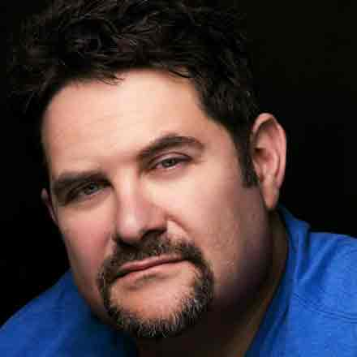 Michael Wechsler (Writer/Director/Producer) — Michael co-founded Rowish Productions and under that banner, wrote, directed and edited the critically acclaimed, psychological thriller ‘Altered Minds’, starring Academy Award nominated actor Judd Hirsch and rising star Ryan O’Nan.
In 1999, Wechsler wrote, directed and edited ‘Slaves of Hollywood’, a feature accepted at more than thirty-five film festivals worldwide. ‘Slaves of Hollywood’ won ‘Best Feature’ at the Rhode Island Film Festival and the ‘Production Excellence’ award at the Troia Festival in Portugal. The film was picked up for theatrical distribution in Los Angeles, where it received glowing reviews from top critics, including Kenneth Turan of Los Angeles Times. Wechsler has also written the screenplay ‘Hangmen’ for Village Roadshow Pictures and the sci-fi feature Sky Bar for MirageQuest Studios.
A professional avid editor for the last 15 years, Wechsler successfully segued into developing original content, producing and directing for television. He sold the series ‘Meeting the Family’ to Spike TV, and worked on projects for British Broadcasting Corporation, TLC, History Channel and Travel Channel. He’s directed more than 50 hours of episodic, non-fiction programming including TLC’S top rated, ‘What Not to Wear,’ Travel Channel’s ‘Samantha Brown’ and ‘Tim Gunn’s Guide to Style’ on Bravo.
For online content, Wechsler was commissioned to create, write and direct two new series ‘Celebrity Home Video’ and ‘The Last Date for Always Independent Films’. Two shorts ‘Brace Yourself’ and ‘Young Seinfeld’ were born from these series, becoming instant YouTube sensations, boasting over 25 million views collectively. He’s currently in preproduction to expand both series and capitalize on their burgeoning fan base.
Wechsler graduated from the NYU Tisch School of Arts Film Program, and resides in South Orange, NJ, with his wife and 2 boys.

 Shawn R. Singh (Producer) — Shawn Singh formed Rowish Productions with Michael Wechsler in 2009 and co-produced the feature film ‘‘Altered Minds’’. He is also Executive Producer of Josh Zeman and Adrian Grenier documentary, ‘52: In Search of the Loneliest Whale in the World’.
Mr. Singh is General Counsel and Managing Director for a multi-billion dollar global hedge fund in New York. Prior to his legal career, Mr. Singh owned mKarma Productions, a production company responsible for producing live shows, entertainment events and business consulting services to feature films and serials in South Asia.

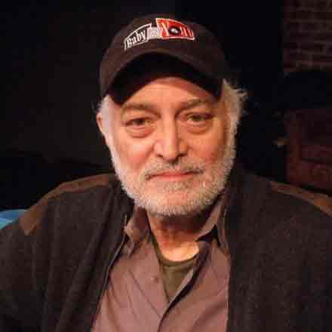 Jonathan Sanger (Executive Producer) — Academy Award winning Producer Jonathan Sanger has enjoyed a long and successful career as a film, television, and theatre producer. To date his films have received 3 Academy Awards, 21 Academy Award nominations, a British Academy Film Award and a French Cesar. Jonathan’s film producing credits include ‘The Producers – The Musical’ (based on the Mel Brooks Broadway musical and motion picture), for Universal & Sony. Sanger Executive Produced the Warner Brothers feature, ‘Without Limits’, starring Billy Crudup and Donald Sutherland, ‘Suspect Zero’ and ‘Vanilla Sky’, starring Tom Cruise and Penelope Cruz, written and directed by Cameron Crowe. Jonathan’s first produced film was ‘The Elephant Man’, directed by David Lynch.

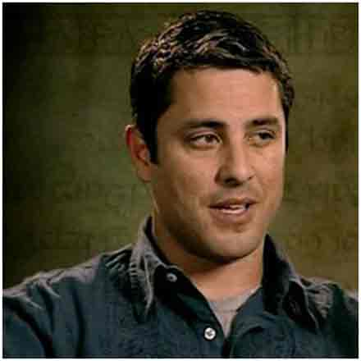 Rick Porras (Executive Producer) — Rick Porras became a top-tier industry producer working with Robert Zemeckis on ‘Forrest Gump’, ‘Contact’, ‘Death Becomes Her’, ‘Public Eye’, ‘The Frighteners’, and ‘The Beatles Anthology Music Videos’. As a result of his experience on ‘The Frighteners’, Peter Jackson tapped Rick to co-produce the ‘The Lord of the Rings’ trilogy, beginning a six and a half year journey in New Zealand that included Second Unit Director credit.

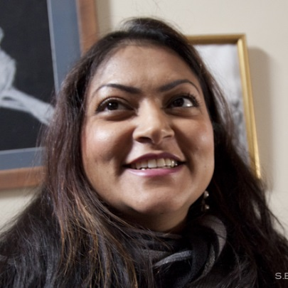 Khush Singh (Executive Producer / Key Makeup Artist) — Khush started out in the entertainment industry as an independent director and TV News Reporter for TV Asia. In addition to creating cover looks for magazines, celebrities, and make-up for fashion shows, Khush has been the key makeup artist on several TV shows and pilots. She is the author of 2 books: The Asian Women: Beauty and Glamour and The Eyes Have It.

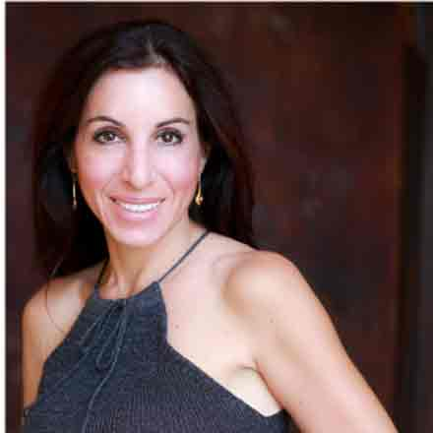 Wendy Herst (Executive Producers) — Wendy Pronin Herst grew up in the Big Apple and began her career in the entertainment industry at the training program (aka the mailroom) at Agency for the Performing Arts (APA). She moved onto International Creative Management (ICM) to work as an Agent Assistant in the TV/Film Talent department. Since she has discovered her true calling and went on to build two successful recruiting firms, The Human Capital Group and Emerald Health Services.

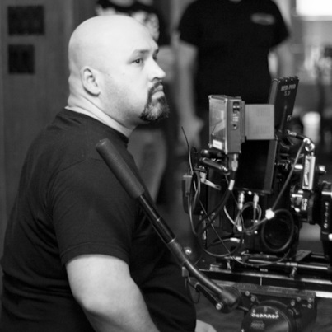 Adrian Correia (Director of Photography) — Adrian built an impressive career on an extensive resume of features, short films, documentaries, commercials, promos, television, web series and music videos. Aside from ‘Altered Minds’, Adrian’s recent feature credits include ‘Dead Souls’, ‘Junction’, ‘Art Machine’, ‘Zerosome’ and ‘Sinking Sands’. Adrian truly loves being on set, regardless of what challenges arise.

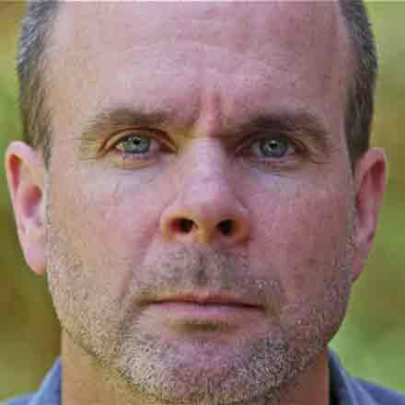 Tom Swartwout (Editor) — Tom Swartwout edited Sidney Lumet’s last four feature films, including ‘Before the Devil Knows You’re Dead’, and ‘Find Me Guilty’. He has edited feature films, documentaries, and television series for over fifteen years. Tom worked with acclaimed editor Sam O’Steen for several years on such films as ‘Wolf’ and ‘Night Falls on Manhattan’.

 Edmund Choi (Composer) — Composer Edmund Choi began his career with director M. Night Shyamalan writing the music for his first two features, ‘Praying with Anger’ and ‘Wide Awake’. He was signed to a multi-picture deal by Harvey Weinstein to compose music for Miramax Films. Through his ongoing partnership with Working Dog Productions, he has been honored to have scored two of Australia’s most beloved films, ‘The Castle’ and ‘The Dish’.

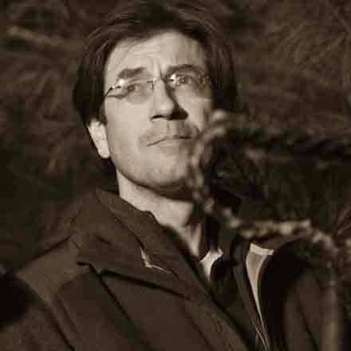 David Barnes (Production Designer) — Prior to ‘Altered Minds’, contributed his artistic talents to projects such as the ‘How Do You Know?’, starring Reese Witherspoon and Jack Nicholson, M. Night Shyamalan’s ‘The Last Airbender’ and ‘The Sixth Sense’, as well as the classic ‘Field Of Dreams’. Dave served as Production Designer on the feature film ‘Lebanon, PA’, an award-winning official selection at the SXSW Film Festival, and his other Production Design credits include ‘Bottleworld’, ‘Shadow: Dead Riot’, and ‘Snipes’ starring Zoe Saldana and Nelly.

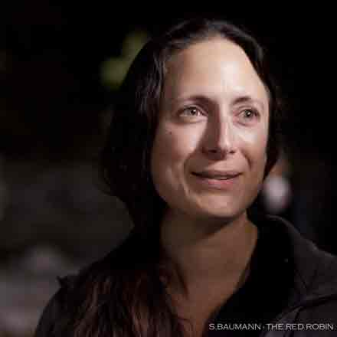 Gina Scarnati (Costume Designer) — Gina Scarnati was the milliner on ‘The Hunger Games’ and helped shape the look for many of the unmistakable hats worn by the characters. She is the set costumer for ‘Paranoia’, starring Harrison Ford and Gary Oldman and specialty costume manufacturer for NBC series ‘Revolution.’

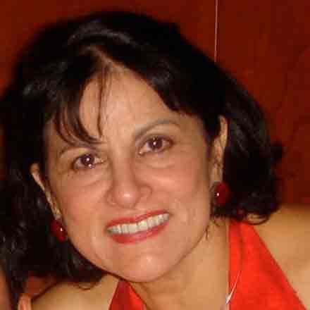 Sarab Zavaleta (Co-Producer) — Born in India, Sarab Zavaleta, arrived in the US with $10 in her pocket in the mid-60s, and spent the first year in a mid-west college in Missouri. After relocating to New York she earned her BA from Barnard College in Economics and film. Her passion for film and film-making led to her involvement in ‘Altered Minds’.

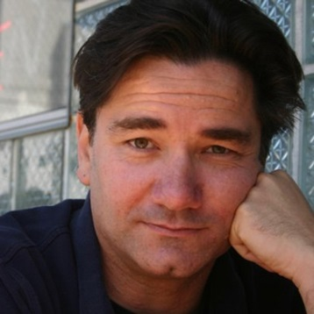 Terry Keefe (Co-Producer) — Terry Keefe is a writer-director who co-created ‘Slaves of Hollywood’ with Michael Wechsler. He has sold shows to and developed projects with Spike TV and Double Nickel Entertainment. He is currently writing the popular web-comic TESLA which has garnered a fan base of over 1 MILLION weekly visitors.
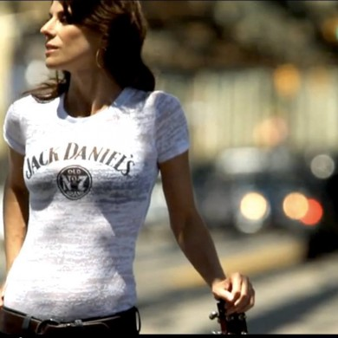 Erin Sax Seymour (Singer / Songwriter) — Erin Sax performs the track ‘Happy’ in ‘Altered Minds’ that she co-wrote with Pat Kelly. Erin’s music is whiskey-soaked, “with an anachronistic flair for sexy, southern-style tunes to beat the country and blues at their own game.” -Feast of Music. The great producer Clay Holley (Amy Winehouse, Adele, and John Legend) has stewarded Erin’s unique sound and on the road she can be seen in legendary venues (B.B. King's, Tipitina's, The House of Blues, The Triple Door and The Double Door) as well as sharing the stage with bad boy Robert Earl Keen and The Samples. [www.erinsax.com | facebook.com/erinsax | twitter @erinsax]

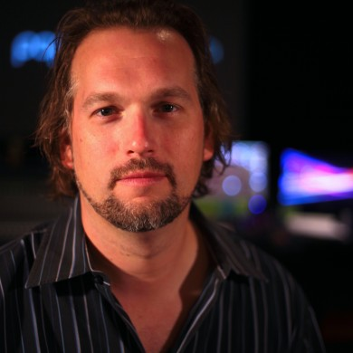 Kevin Hill (Supervision Sound Editor/Re-recording Mixer) — Kevin is an engineer/producer who began his career 20 years ago. In 2001, he launched Studio Unknown, an audio post production facility. Kevin’s sound design and original music have been featured in film, TV, Web, stage productions, and video games. Kevin recently served as the Supervising Sound Editor and Re-recording Mixer for ‘Lovely Molly’, a film by Eduardo Sanchez (‘Blair Witch Project’).

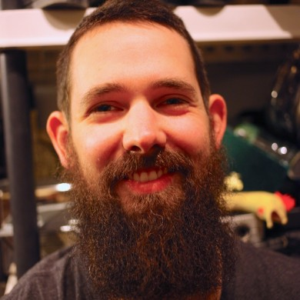 Matt Davies (Sound Designer/Editor) — Matt is a Sound Designer, Sound Effects Editor and Foley Artist working at Studio Unknown in Catonsville, Maryland. Matt builds custom instruments for use in creating unique and visceral sounds for use in feature film sound design. Some of his recent feature film credits include ‘Lovely Molly’ (Haxan Films), ‘Altered Minds’ (Dir: Michael Wechsler) and the up and coming ‘VHS 2’ (Haxan Films).

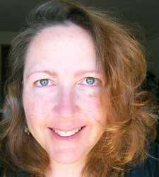 J. S. Crail (Director of Marketing & Social Media) — Suzanne is an award-winning screenwriter ‘The Watershed’, has completed her first novel in a trilogy, and intends to produce for stage and screen. She is serial entrepreneur, designer, and educator. She holds a graduate certificate in Professional Screenwriting from UCLA, a B.S. in Business Econ, and a Montessori ECE credential. As CEO of Anima Wave, Suzanne is dedicated to promoting and distributing transmedia content and products to inspire creative compassion. As Director of Marketing & Communications for TriNet, she helped grow the company into an international market leader ranking in Fortune Magazine’s ‘Top 500 Fastest Growing Companies’ for 5 consecutive years of her tenure.

Lynne Kressel & Kevin Kuffa (Casting Directors) — Lynn Kressel is an Emmy Award winning Casting Director and Producer. In 1989 Lynn Kressel won the first ever Emmy Award for Outstanding Achievement in Casting for a Miniseries or a Special for a miniseries based on Larry McMurtry’s novel Lonesome Dove. Kressel’s casting of ‘Law & Order’ remains a highlight of her career. She also cast ‘Spiderman’, ‘Don Juan De Marco’, and ‘For Love of the Game’, ‘The Rundown’ and Ricky Gervais’s ‘The Invention Of Lying’.
Kevin Kuffa is a Casting Director with Lynn Kressel Casting, working on TV and film out of New York and Los Angeles. He cast the independent feature films ‘Beach Pillows’ with Vincent Kartheiser, Geoffry Arend, Richard Schiff, and Annette O’Toole, in addition to casting Eric Mendelsohn’s Sundance award winner ‘3 Backyards’ with Edie Falco, Embeth Davidtz, and Elias Koteas. Other recent projects include ‘Law & Order: Criminal Intent’, the NBC pilot ‘Chicago Fire’, and Jean-Pierre Jeunet’s upcoming ‘The Selected Works of T.S. Spivet’

LONG SYNOPSIS
‘Altered Minds’ is a tense psychological thriller unraveling the troubled past, conflicted present, an uncertain future of the remarkable Shellner family.
75 year-old Dr. Nathaniel Shellner’s led an extraordinary life as a psychiatrist treating patients traumatized in war zones and earning a Nobel Prize for his work. After having one child, Leonard (48), Nathaniel and his wife Lillian (72), adopted the remainder of their family from the camps where Dr. Shellner worked – Tommy (36), Julie (38), and Harry (37). As Dr. Shellner lies on his death bed in a bitter New Jersey winter, his children gather at the family home for his last birthday, to bid a final farewell to the great man. All goes to plan until Tommy, on the cusp of insanity tries to pry dark family secrets from his father before he dies. Tommy is tormented by visions and accuses his father of adopting them not out of love and concern, but to use them for psychological experimentation. The stunned family resents Tommy’s implications, becoming protective of Dr. Shellner’s health and reputation as a paragon of selflessness and virtue. Through dismissed as disturbed and traumatized, Tommy’s determination opens a door to the past that threatens to unravel his father’s credibility and character.

ALTERED MINDS PRODUCTION SPECS
Title: Altered Minds (2015)
Category: Feature
Genre: Psychological Thriller
Running Time: 93 minutes
Orig. Format: Hi-Def – RED EPIC
Country of Origin: USA
Website: Altered-Minds.com
Twitter: @AlteredMindsMOV
Instagram: Rowish Films
Facebook: Altered Minds MOVIE
Tumblr: Rowish
Google+: RowishProductions
YouTube: AM Teaser Trailer – https://youtu.be/Q3aVsG_OC1o
Embed – <iframe width="560" height="315" src="https://www.youtube.com/embed/Q3aVsG_OC1o" frameborder="0" allowfullscreen></iframe>

